Calculator

MainActivity.kt:-

package com.example.helloworld  
  
import android.annotation.SuppressLint  
import androidx.appcompat.app.AppCompatActivity  
import android.os.Bundle  
import android.widget.EditText  
import android.widget.Button  
import android.widget.TextView  
import android.widget.Toast  
  
class MainActivity : AppCompatActivity() {  
 @SuppressLint("MissingInflatedId")  
 override fun onCreate(savedInstanceState: Bundle?) {  
 super.onCreate(savedInstanceState)  
 setContentView(R.layout.*activity_main*)  
  
 var text1: EditText = findViewById(R.id.*EditText1*);  
 var text2: EditText = findViewById(R.id.*EditText2*);  
 var text3: TextView = findViewById(R.id.*TextView2*);  
 var btn1: Button = findViewById(R.id.*add*);  
 var btn2: Button = findViewById(R.id.*sub*);  
 var btn3: Button = findViewById(R.id.*mul*);  
 var btn4: Button = findViewById(R.id.*div*);  
 var btn5: Button = findViewById(R.id.*clr*);  
  
 btn1.setOnClickListener **{** var num1 = Integer.parseInt(text1.*text*.toString())  
 var num2 = Integer.parseInt(text2.*text*.toString())  
  
 var sum = num1 + num2;  
 text3.setText("Addition is " + sum)  
  
 Toast.makeText(*applicationContext*, "Addition is Successfull..........", Toast.*LENGTH_LONG*).show()  
 **}** btn2.setOnClickListener **{** var num1 = Integer.parseInt(text1.*text*.toString())  
 var num2 = Integer.parseInt(text2.*text*.toString())  
  
 var sum = num1 - num2;  
 text3.setText("Substraction is " + sum)  
  
 Toast.makeText(*applicationContext*, "Substraction is Successfull..........", Toast.*LENGTH_LONG*).show()  
 **}** btn3.setOnClickListener **{** var num1 = Integer.parseInt(text1.*text*.toString())  
 var num2 = Integer.parseInt(text2.*text*.toString())  
  
 var sum = num1 * num2;  
 text3.setText("Multiplication is " + sum)  
  
 Toast.makeText(*applicationContext*,"Multiplication is Successfull..........",Toast.*LENGTH_LONG*).show()  
 **}** btn4.setOnClickListener **{** var num1 = Integer.parseInt(text1.*text*.toString())  
 var num2 = Integer.parseInt(text2.*text*.toString())  
  
 var sum = num1 / num2;  
 text3.setText("Division is " + sum)  
  
 Toast.makeText(*applicationContext*, "Division is Successfull..........", Toast.*LENGTH_LONG*).show()  
 **}** btn5.setOnClickListener **{** text3.setText(" Cleared ")  
  
 Toast.makeText(*applicationContext*, "Cleared..........", Toast.*LENGTH_LONG*).show()  
 **}** }  
}

activity_main.xml:-

*<?*xml version="1.0" encoding="utf-8"*?>*<androidx.constraintlayout.widget.ConstraintLayout xmlns:android="http://schemas.android.com/apk/res/android"  
 xmlns:app="http://schemas.android.com/apk/res-auto"  
 xmlns:tools="http://schemas.android.com/tools"  
 android:layout_width="match_parent"  
 android:layout_height="match_parent"  
 tools:context=".MainActivity">  
  
 <TextView  
 android:id="@+id/textView2"  
 android:layout_width="192dp"  
 android:layout_height="54dp"  
 android:layout_marginStart="24dp"  
 android:layout_marginTop="28dp"  
 android:layout_marginEnd="24dp"  
 android:fontFamily="@font/alegreya_sans_sc_italic"  
 android:text="CALCULATOR"  
 android:textColor="#E91E63"  
 android:textColorHighlight="#3F51B5"  
 app:autoSizeTextType="uniform"  
 app:layout_constraintBottom_toBottomOf="parent"  
 app:layout_constraintEnd_toEndOf="parent"  
 app:layout_constraintHorizontal_bias="0.485"  
 app:layout_constraintStart_toStartOf="parent"  
 app:layout_constraintTop_toTopOf="parent"  
 app:layout_constraintVertical_bias="0.033" />  
  
 <EditText  
 android:id="@+id/EditText1"  
 android:layout_width="197dp"  
 android:layout_height="55dp"  
 android:layout_marginStart="24dp"  
 android:layout_marginTop="28dp"  
 android:layout_marginEnd="24dp"  
 android:ems="10"  
 android:inputType="textPersonName"  
 app:layout_constraintEnd_toEndOf="parent"  
 app:layout_constraintHorizontal_bias="0.469"  
 app:layout_constraintStart_toStartOf="parent"  
 app:layout_constraintTop_toBottomOf="@+id/textView2"  
 tools:ignore="MissingConstraints,SpeakableTextPresentCheck" />  
  
 <EditText  
 android:id="@+id/EditText2"  
 android:layout_width="197dp"  
 android:layout_height="59dp"  
 android:layout_marginStart="24dp"  
 android:layout_marginEnd="24dp"  
 android:ems="10"  
 android:inputType="textPersonName"  
 app:layout_constraintBottom_toBottomOf="parent"  
 app:layout_constraintEnd_toEndOf="parent"  
 app:layout_constraintHorizontal_bias="0.476"  
 app:layout_constraintStart_toStartOf="parent"  
 app:layout_constraintTop_toBottomOf="@+id/EditText1"  
 app:layout_constraintVertical_bias="0.036"  
 tools:ignore="SpeakableTextPresentCheck" />  
  
 <Button  
 android:id="@+id/add"  
 android:layout_width="159dp"  
 android:layout_height="61dp"  
 android:layout_marginStart="28dp"  
 android:layout_marginTop="96dp"  
 android:text="ADD"  
 app:layout_constraintEnd_toStartOf="@+id/sub"  
 app:layout_constraintStart_toStartOf="parent"  
 app:layout_constraintTop_toBottomOf="@+id/TextView2" />  
  
 <TextView  
 android:id="@+id/TextView2"  
 android:layout_width="283dp"  
 android:layout_height="51dp"  
 android:layout_marginStart="24dp"  
 android:layout_marginTop="52dp"  
 android:layout_marginEnd="24dp"  
 android:textAppearance="@style/TextAppearance.AppCompat.Large"  
 app:layout_constraintEnd_toEndOf="parent"  
 app:layout_constraintHorizontal_bias="0.478"  
 app:layout_constraintStart_toStartOf="parent"  
 app:layout_constraintTop_toBottomOf="@+id/EditText2" />  
  
 <Button  
 android:id="@+id/sub"  
 android:layout_width="156dp"  
 android:layout_height="65dp"  
 android:layout_marginTop="92dp"  
 android:layout_marginEnd="28dp"  
 android:text="SUB"  
 app:layout_constraintEnd_toEndOf="parent"  
 app:layout_constraintTop_toBottomOf="@+id/TextView2" />  
  
 <Button  
 android:id="@+id/mul"  
 android:layout_width="150dp"  
 android:layout_height="63dp"  
 android:layout_marginStart="28dp"  
 android:layout_marginTop="36dp"  
 android:text="MUL"  
 app:layout_constraintEnd_toStartOf="@+id/div"  
 app:layout_constraintHorizontal_bias="0.392"  
 app:layout_constraintStart_toStartOf="parent"  
 app:layout_constraintTop_toBottomOf="@+id/add" />  
  
 <Button  
 android:id="@+id/div"  
 android:layout_width="154dp"  
 android:layout_height="65dp"  
 android:layout_marginTop="36dp"  
 android:layout_marginEnd="28dp"  
 android:text="DIV"  
 app:layout_constraintEnd_toEndOf="parent"  
 app:layout_constraintTop_toBottomOf="@+id/sub" />  
  
 <Button  
 android:id="@+id/clr"  
 android:layout_width="172dp"  
 android:layout_height="62dp"  
 android:layout_marginTop="40dp"  
 android:text="CLEAR"  
 app:layout_constraintEnd_toEndOf="parent"  
 app:layout_constraintHorizontal_bias="0.497"  
 app:layout_constraintStart_toStartOf="parent"  
 app:layout_constraintTop_toBottomOf="@+id/mul" />  
  
</androidx.constraintlayout.widget.ConstraintLayout>

Output:-

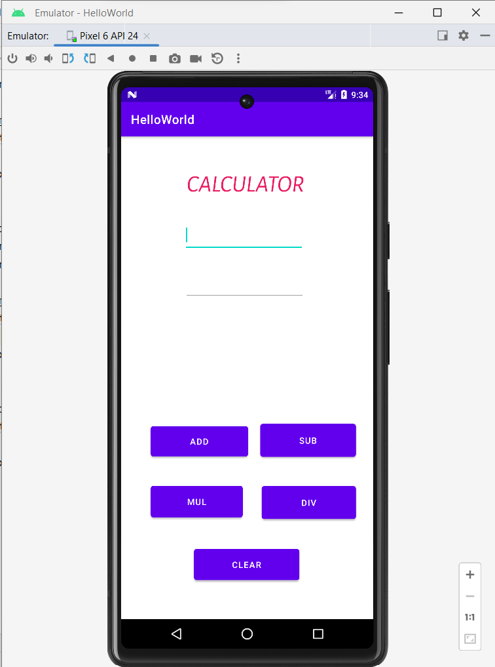

Addition:-

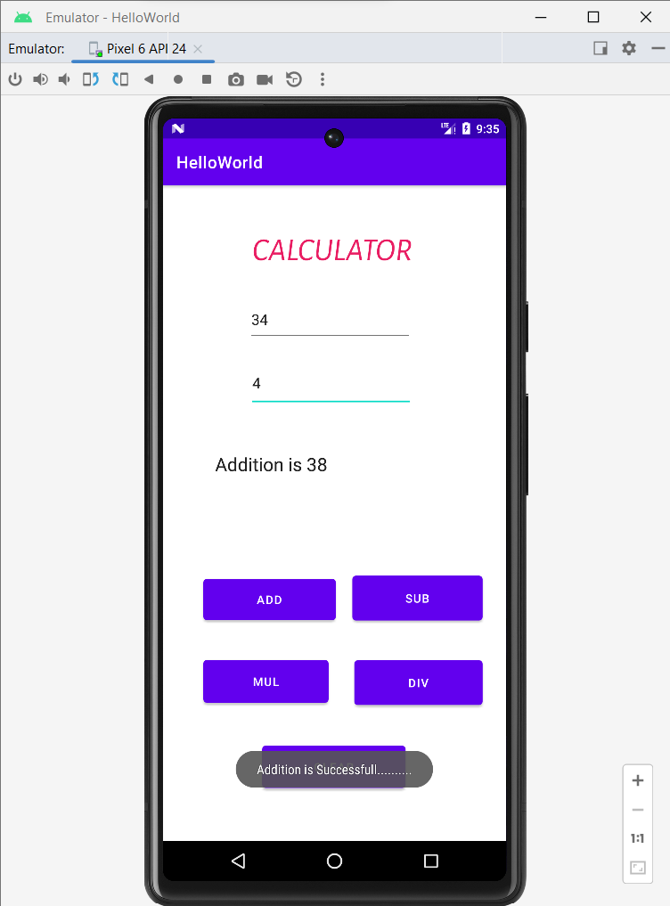

Substraction:-

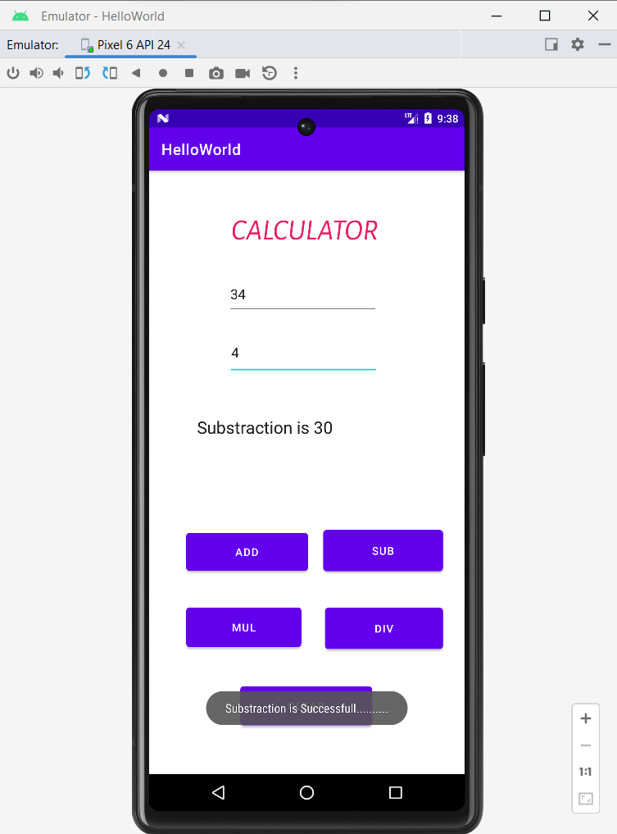

Multiplication:-

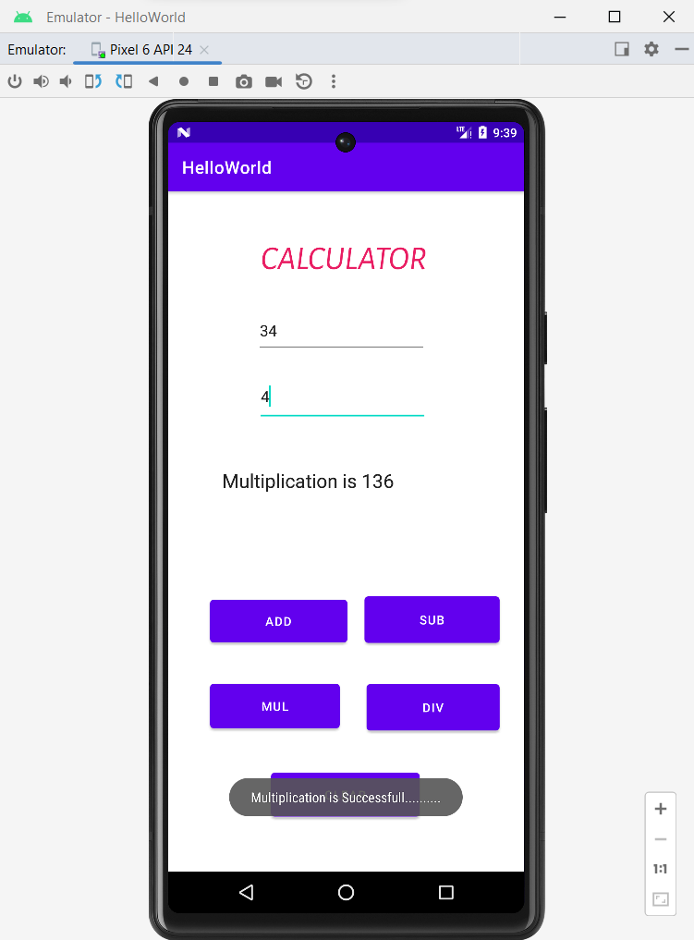

Division:-

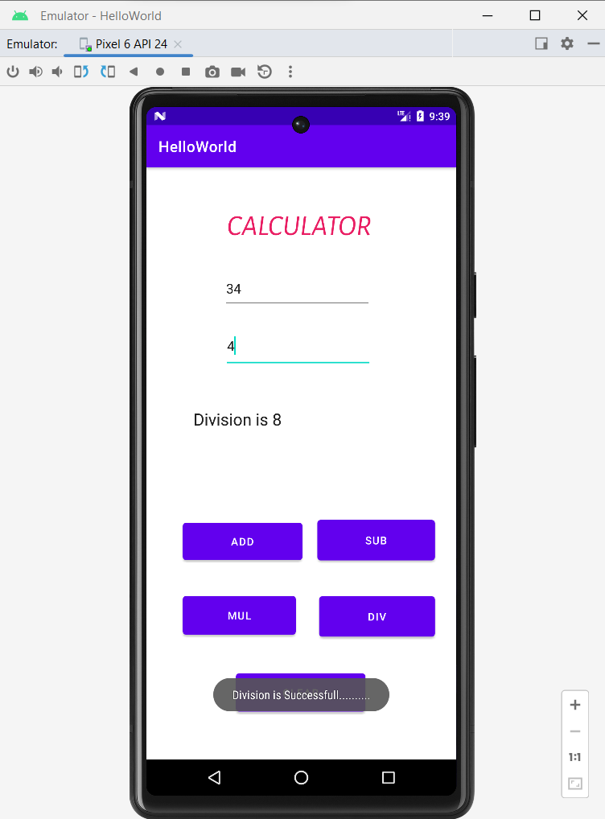

Clear:-

